FIT3138 Assignment 1 Part 2

Production Planning and Supply Chain Management

Data Sheet

Name : Rui Qin

Student Id : 30874157

Tutorial No : 02

SAP Id (LEARN-###) Learn-031

Instructions :

1. Complete your details above.
2. Copy and paste the five screenshots where indicated. Screenshots must be clear and easily readable.
3. Write you reflective essay on the last page (approx. 300 words)
4. Save the document as AAAA-9999999 Part 1.docx (or .pdf) where AAAA is your last name and 9999999 is your Student ID e.g. Smith-3678999 Part 1.docx
5. Upload the document to the submission link in Moodle.

Step A: Material Component Overview

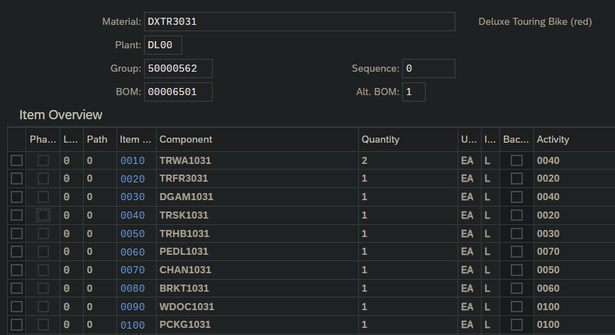

Step B: Change Rough-Cut Plan

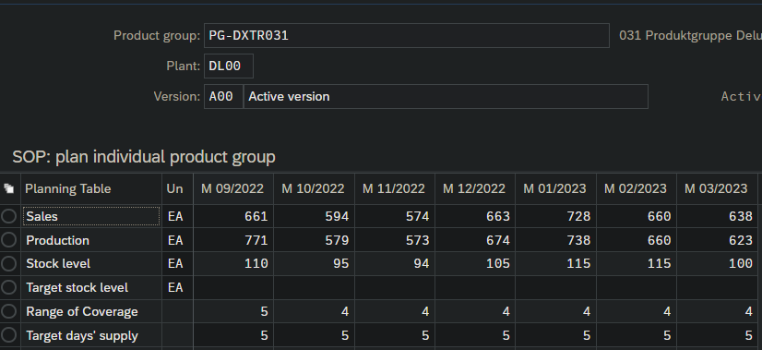

Step C: Pegged Requirements

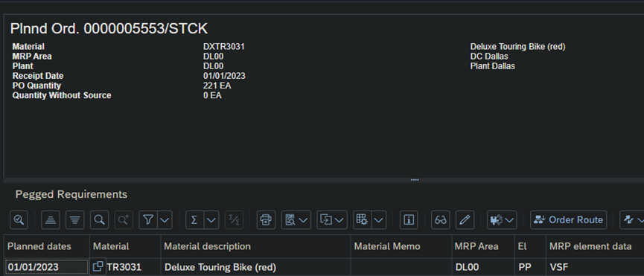

Step D: Target/Actual Comparison

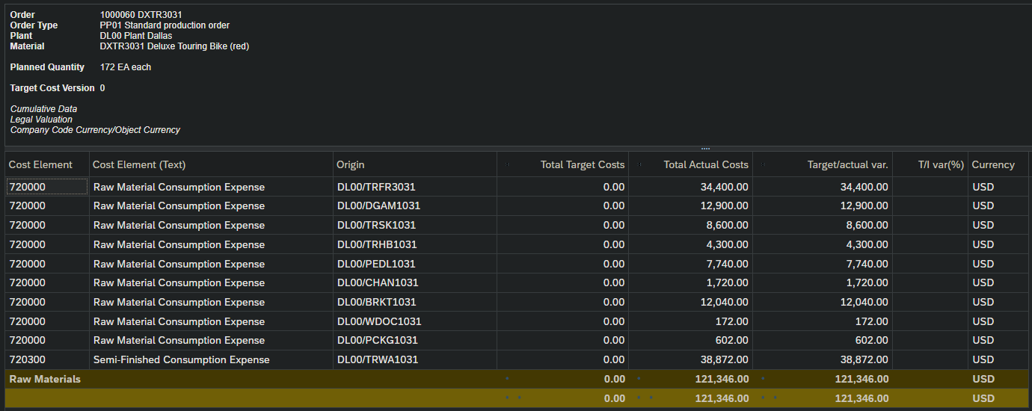

Step E: Orders: Actual/Plan/Variance

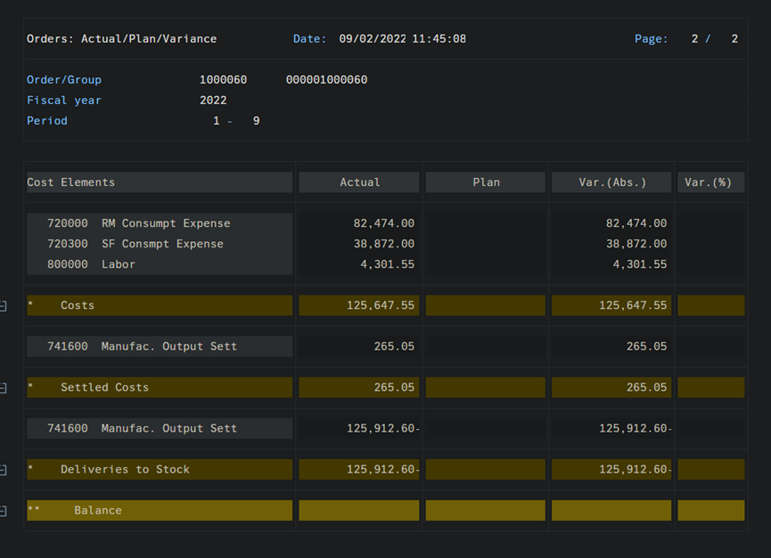

Reflective Essay

SAP_PP included the bill of material, routing, work centre and material.

## Bill of material

Bill of material is the total structured list of the production which includes the number of components, it is also required in material requirement and costing calculation. For products with variants such as Trek Bike and Trek Bike Silver, a super BOM can contain all possible types of components and select components with specific features at the time of sale to make up for the customer's desired product.

## Routing

Routing is used to record the cost and the schedule of the material production. It includes quantity and production activities such as packing the bike.

## Work centre

The work centre is used for task list operations, the data include schedule, costing and work centre capacity

## Material

In the material section, the basic purpose is collecting all the information about the material, which includes production, store, and selling information, these data make the material unique. Material with the same attributes is assigned a kind of material type such as raw material.

During my practice on the SAP supply chain system, I found that the goal of IT in the SAP supply chain is to seamlessly connect the production point with the delivery point or the purchase point. At the same time, we can track the product planning, transportation and delivery process through information, which improves the visualization of the supply chain. When using the SAP supply chain function, we need to fill in product information and time more fully, so as to provide enough supply chain information for managers to make data analysis and business decisions. That's because the software can make predictions about when and how much of a particular product will need to be produced, and those predictions are based on the data we're based on, which means that the more information it has, the more accurate the predictions it can provide.

At the same time, the supply chain system enhances the degree of cooperation and communication between customers and suppliers. Thanks to the visualization of the supply chain, customers can learn more supply chain information from the software, so as to discover new ideas and then communicate with suppliers. Suppliers can also participate in the supply chain, thus developing a good cooperative relationship, which greatly improves the efficiency of the supply chain.

In addition, the supply chain system can provide a variety of information such as the success of cost calculation, which can facilitate customers to calculate their own supply costs to optimize their profits. This greatly improves the work efficiency of the supply chain, and can also enhance the related efficiency of supply chain management